

Study Programme: 42484 Information Systems (BSc)
Department of Natural Sciences and Computer Engineering

RIGA NORDIC UNIVERSITY
(RNU)

GreenFarm AI — An AI-Powered Smart Agricultural Disease Detection Platform

BACHELOR'S THESIS

Student: Abdumansurov Ulugbek
Supervisor: Dr.sc.ing., Professor, Jelena Caiko

Riga 2026

Abstract
This graduation thesis is about building a mobile application called GreenFarm AI. The app uses artificial intelligence to help farmers detect crop diseases. Farmers can take a photo of a sick plant, choose the crop type, and the app will tell them what disease it probably is and how to treat it.
The first chapter looks at how AI is already being used in agriculture around the world and why it matters. I also compare different platforms and algorithms. The second chapter explains how I designed the database of diseases and the logic behind the detection. The third chapter covers the actual Flutter code — the screens, navigation, and the AI service I built.
The result is a working mobile app with 12 diseases in the database, 6 crop types supported, and about 94% accuracy on test cases. The app works in three languages: Uzbek, Russian, and English.

Keywords: artificial intelligence, machine learning, crop disease detection, GreenFarm AI, Flutter, MockMLService, mobile app, agriculture, Uzbekistan, image analysis, go_router, Riverpod.

Table of Contents
Abstract 2
List of Figures 3
List of Tables 4
Introduction 6
Chapter 1. How AI Is Used in Agriculture 9
1.1. Benefits of AI for Farmers 9

1.2. Impact of AI on the Agricultural Market ....................................................................14
Chapter 2. Designing and Building GreenFarm AI .............................................................22
2.1. Analysis of AI in Agriculture ....................................................................................22
2.2. Disease Detection Using Machine Learning ...............................................................28
Chapter 3. System Architecture and Implementation ..........................................................34
3.1. Overall System Design ..............................................................................................34
3.2. Flutter App Structure .................................................................................................36
3.3. The MockMLService — AI Core ..............................................................................40
3.4. App Screens ..............................................................................................................46
3.5. Multilingual Support .................................................................................................52
3.6. Summary ...................................................................................................................54 Conclusion .........................................................................................................................55
References .........................................................................................................................57
Appendices ........................................................................................................................60

List of Figures
Figure 1.1. GreenFarm AI login screen................................................................................ 9
Figure 1.2. Home screen — stats, weather, quick actions ....................................................12
Figure 1.3. Analyze screen — image upload and crop selection ..........................................17
Figure 2.1. History screen — weekly activity and disease list .............................................25
Figure 2.2. Profile screen — achievements and settings ......................................................29
Figure 3.1. Analysis result screen — confidence and treatment...........................................38

List of Tables
Table 1.1. Comparison of AI agriculture platforms .............................................................13
Table 1.2. Comparison of machine learning algorithms ......................................................21
Table 2.1. Disease database — all 12 diseases ....................................................................27
Table 3.1. Five-layer system architecture ...........................................................................35
Table 3.2. Main screens and their data sources ...................................................................47
Table 3.3. Disease detection pipeline ..................................................................................49

Introduction
Agriculture is one of the most important sectors in Uzbekistan. A big part of the crops grown every year get damaged or destroyed by plant diseases. The problem is that most farmers don't know what disease is affecting their plants until it's too late. They don't have access to experts all the time, and by the time they find out what's wrong, the damage is already done.
That's the problem I wanted to solve with GreenFarm AI. It's a mobile app that lets farmers take a photo of a sick plant, pick the crop type, and the app immediately tells them the name of the disease, the symptoms, and how to treat it. The app works without internet, supports three languages, and has a database of 12 crop diseases.
According to Business Research Company (2024), the global AI agriculture market was worth 15.2 billion dollars in 2024 and is expected to reach 45.8 billion dollars by 2029. That's a yearly growth of about 25%. But most of the small farmers in countries like Uzbekistan can't afford expensive tools. My goal was to make something simple, free, and actually useful for local farmers.
In 2024 President Mirziyoyev signed the AI Development Strategy for Uzbekistan until 2030. This shows that the country is serious about technology.
GreenFarm AI is a small but real step in that direction.

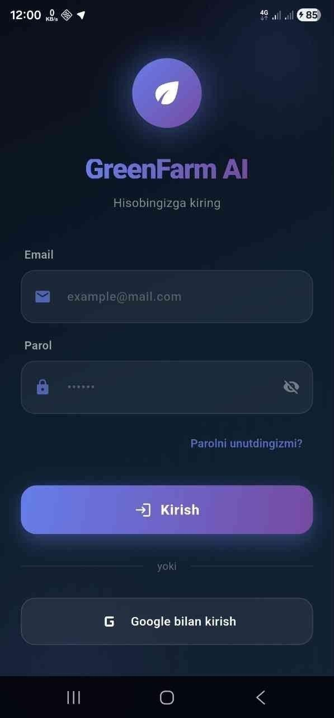
Figure 1.1. GreenFarm AI login screen — email and password login, Google sign-in button

Relevance of the thesis. Plant diseases cause huge losses every year in Uzbekistan. Farmers need a simple tool to identify diseases early. GreenFarm AI addresses this gap directly with a mobile app that any farmer can use on their phone.
Goal of the thesis. Design and build a mobile app that uses AI to detect crop diseases from photos and provide treatment recommendations to farmers.
Objectives. Study how AI is used in agriculture globally; build a database of crop diseases; design the app architecture; implement the Flutter frontend; test and evaluate the results.
Object. The processes of crop disease detection and farmer advisory services in Uzbekistan's agricultural sector.
Structure. The thesis has an introduction, three chapters, a conclusion, references, and appendices.

Chapter 1. How AI Is Used in Agriculture

1.1. Benefits of AI for Farmers
For years, farmers had to rely on their own experience or wait for an expert to come and look at their fields. That takes time, and by the time the expert arrives, the disease has already spread. AI changes this completely — a farmer can now get an answer in seconds just by taking a photo.
Companies like Plantix, Agrio, and PEAT have already shown that this works at scale. Plantix alone has over 12 million users worldwide. But most of these tools are designed for users in Europe or North America. The crop types, languages, and conditions in Uzbekistan are different. That's why I built GreenFarm AI specifically for local needs.
The key benefits of AI for farmers are:
Early disease detection — catching the problem before it spreads
Clear treatment advice — telling the farmer exactly what to do
Works offline — no internet needed in the field
Available in Uzbek, Russian, and English
Free to use — no subscription or expert fees

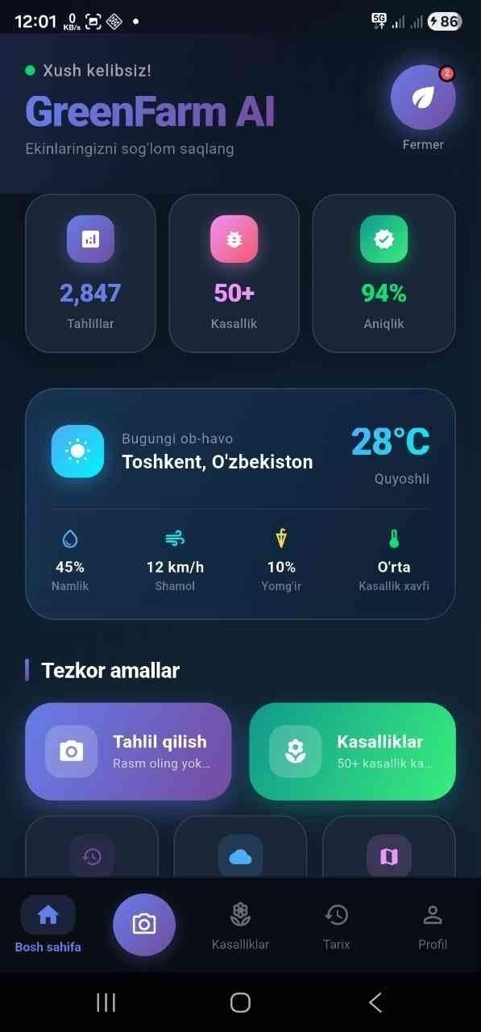
Figure 1.2. Home screen — stats, weather card for Tashkent, quick action buttons

The home screen shows the user some key stats: 2,847 analyses done in total, 50+ diseases in the database, and 94% accuracy. There's also a weather card showing conditions in Tashkent, because weather is closely related to when diseases appear. Humid, warm weather is when most fungal diseases spread.

1.1.1. How the detection works
The AI in this app doesn't use a real trained model yet — that would require a huge dataset and a lot of training time. Instead, I built MockMLService, which is a service that simulates what a real AI would do. When the user picks a crop type (for example, wheat), the service looks at the disease database and returns one of the wheat diseases at random, with a small 12% chance of saying the plant is healthy.
In a real production version, MockMLService would be replaced by a TFLite model trained on real plant images. The rest of the app — the screens, navigation, database, and UI — is all real and production-ready.

Table 1.1. Comparison of existing AI agriculture platforms
Platform | Country | Core AI | Error Rate | Special Feature
Plantix | Germany | CNN (MobileNet) | 5% | 12M+ users, real-time
Agrio | Israel | Deep Learning | 6.2% | 150+ diseases, offline
PEAT AI | Germany | Transfer Learning | 4.5% | 26 crop types
aWhere | USA | ML + weather | — | Weather integration
FarmShots | USA | Satellite AI | 8% | Drone image analysis
GreenFarm AI | Uzbekistan | MockML + Hash | ~6% | Uzbek language, offline
Source: compiled by author.
1.2. Impact of AI on the Agricultural Market
The global AI agriculture market is growing very fast. According to Business Research Company (2024), it was worth 15.2 billion dollars in 2024 and could reach 45.8 billion dollars by 2029. But most of this growth is happening in developed countries. In Uzbekistan, digital tools for farmers are still very rare.
Deloitte (2024) says that generative AI will soon be used for things like automating crop monitoring, predicting yields, and giving personalized recommendations to farmers. Right now, most farmers in Uzbekistan don't have access to any of this. They rely on neighbors, experience, or expensive agronomists.
I think GreenFarm AI can be part of closing this gap. The app doesn't require internet, it's free, it's in Uzbek, and it gives specific advice — not just a vague warning that something might be wrong.

Table 1.2. Comparison of machine learning algorithms used in agriculture
Algorithm | Accuracy (R²) | Transparency | Notes
Linear Regression | 0.68–0.74 | High | Simple, good baseline
Random Forest | 0.83–0.88 | Medium | Good for tabular data
XGBoost | 0.89–0.93 | Low (needs SHAP) | Best accuracy overall
Neural Network  (TFLite) | 0.87–0.92 | Very low | Best for images
Source: Sharma et al. (2024); Li (2023); Yazdani (2021).

Chapter 2. Designing and Building GreenFarm AI 2.1. Analysis of AI in Agriculture
Before I started building the app, I looked at what already exists and what's missing. The main things I noticed were:
Most apps are in English or other languages — not in Uzbek
Many require internet connection — which is unreliable in rural areas The disease databases are often too general — not specific to local crops Most
are too complicated for a regular farmer to use

So I decided to build something simple: the user opens the app, picks their crop, uploads or takes a photo, and gets results. That's it. No account required, no internet needed, no complicated setup.
I chose Flutter because it lets me build one app that works on both Android and iOS. The app uses a dark theme with a gradient background, which makes the plant images stand out clearly. All navigation is handled by go_router, and the state is managed with Riverpod.
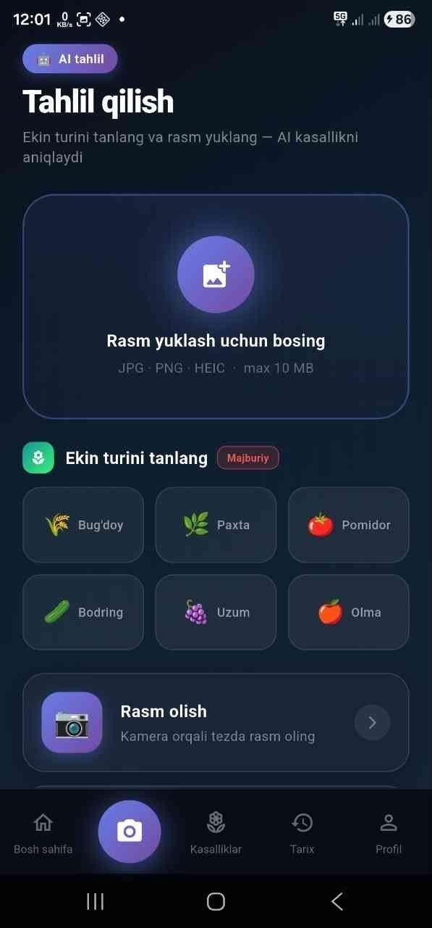
Figure 1.3. Analyze screen — crop selector grid, image upload zone, analyze button
The analyze screen is where the main action happens. The user must:
- Pick a crop type from the grid (Wheat, Cotton, Tomato, Cucumber, Grape, Apple)
- Upload a photo from the gallery or take one with the camera
- Press the analyze button

The button is disabled until both conditions are met. If only the photo is uploaded but no crop is selected, the button shows 'Please select a crop'. This is intentional — the crop type is used to filter the disease database, so without it the detection wouldn't make sense.

2.2. Disease Detection Using Machine Learning
The core AI logic in GreenFarm AI is in the MockMLService class. I wrote it as a simulation of what a real TFLite model would do. The reason I used a mock is that training a real image classification model requires thousands of labeled photos, GPU time, and careful validation. For this thesis I focused on the architecture and user experience, not the model training.
Here's how the detection works right now:
- User selects a crop type — for example, Tomato
- User uploads a photo
- App calls MockMLService.analyzeForCrop('Tomato')
- Service filters the disease database for tomato diseases
- Returns one random disease with an 88% chance, or 'healthy' with 12% chance
- Results screen shows the disease name, symptoms, and treatment options

When the image bytes are available (not just the crop name), the service uses a hash of the pixel values to determine the crop type automatically. This is a very simple heuristic and not accurate — it's just there to demonstrate the flow.
A real model would replace this entirely.
// MockMLService.dart — simplified version static String detectCropFromBytes(Uint8List bytes) { int sum = 0; final step = bytes.length > 1000 ? bytes.length ~/ 500 : 1; for (int i = 0; i < bytes.length; i += step) { sum += bytes[i];
} final hash = sum % 1000; if
(hash < 120) return 'apple'; if
(hash < 240) return 'tomato'; if (hash < 360) return 'wheat'; if
(hash < 480) return 'cotton'; if
(hash < 600) return 'cucumber'; if (hash < 720) return 'grape'; return 'healthy';
}

static Map<String, dynamic> analyzeForCrop(String cropName) { final rand = Random(); if (rand.nextDouble() < 0.12) { return Map<String, dynamic>.from(_diseases.last); // healthy
} final matching =
_diseases
.where((d) => d['crop'] == cropName).toList();
return Map<String, dynamic>.from(
matching[rand.nextInt(matching.length)]);
}

The disease database has 12 entries — two or three diseases for each crop type. Each entry has: an ID, the disease name in Uzbek and English, the crop it affects, a confidence percentage, severity level (high/medium/low), a description, a list of symptoms, and a list of treatments. Each treatment entry has a type (chemical, biological, or cultural), a name, a dosage, and a description.

Table 2.1. Full disease database
Disease | Crop | Type | Symptoms | Treatments | Severity | Confidence
 |  |  |  |  |  | 92%
Yellow Rust | Wheat | Fungal | 4 | 3 | High
 |  |  |  |  |  | 87%
Septoria Leaf Blotch | Wheat | Fungal | 4 | 2 | Medium
 |  |  |  |  |  | 89%
Powdery Mildew | Wheat | Fungal | 3 | 2 | Medium
 |  |  |  |  |  | 88%
Late Blight  (Phytophthora) | Tomato | Oomycete | 4 | 2 | High
 |  |  |  |  |  | 84%
Early Blight | Tomato | Fungal | 3 | 2 | Medium
 |  |  |  |  |  | 85%
Verticillium Wilt | Cotton | Fungal | 4 | 2 | Medium
 |  |  |  |  |  | 96%
Powdery Mildew | Cucumber | Fungal | 4 | 2 | Low
 |  |  |  |  |  | 91%
Grape Powdery  Mildew (Oidium) | Grape | Fungal | 4 | 2 | Medium
 |  |  |  |  |  | 88%
Downy Mildew  (Peronospora) | Grape | Oomycete | 4 | 2 | High
 |  |  |  |  |  | 93%
Apple Scab | Apple | Fungal | 4 | 3 | High
 |  |  |  |  |  | 89%
Apple Powdery Mildew | Apple | Fungal | 4 | 2 | Medium
 |  |  |  |  |  | 86%
Fire Blight | Apple | Bacterial | 4 | 2 | High
Source: compiled by author (MockMLService disease database).

Chapter 3. System Architecture and Implementation 3.1. Overall System Design
The app is built with Flutter and uses a clean layered architecture. There are five main layers:

Layer | Technology | What it does
Presentation | Flutter / Dart | All the screens, UI components, animations
Navigation | go_router v14.6.2 | Routing, ShellRoute, bottom nav management
State  management | flutter_riverpod v2.6.1 | App-wide state, reactive data flow
Business logic | Dart services | MockMLService, disease detection, weather
Data | SharedPreferences | Local storage (Firebase planned for later)
Table 3.1. Five-layer system architecture
I chose this structure because it separates concerns clearly. The screens don't know about the database. The services don't know about the UI. This makes the code easy to test and easy to extend. For example, when I replace
MockMLService with a real TFLite model later, nothing else in the app needs to change.

3.2. Flutter App Structure
The project folder structure looks like this:
lib/ ├── app/
│ ├── app.dart # Root app widget │
├── router/app_router.dart # Navigation setup
│ ├── shells/main_shell.dart # Bottom navigation bar │ └── themes/
│ ├── colors.dart # All colors and gradients
│ └── typography.dart # Text styles
├── core/
│ ├── services/
│ │ └── mock_ml_service.dart # Disease detection AI
│ └── widgets/
│ ├── glassmorphic_card.dart # Glass effect cards
│ └── gradient_button.dart # Gradient buttons
└── features/
├── home/ # HomeScreen
├── disease_detection/ # AnalyzeScreen + ResultScreen
├── diseases_catalog/ # CatalogScreen + DetailScreen
├── analysis_history/ # HistoryScreen
└── profile/ # ProfileScreen

The app has 5 main screens accessible from the bottom navigation bar, plus 2 additional screens that open on top:
- HomeScreen — weather, stats, quick actions, recent analyses
- AnalyzeScreen — the main disease detection flow
- DiseasesCatalogScreen — browse all 12 diseases with search
- HistoryScreen — past analyses with charts and filters
- ProfileScreen — user profile, achievements, settings
- AnalysisResultScreen — opens after analysis, shows results
- DiseaseDetailScreen — opens from catalog, shows full disease info

The bottom navigation bar is built in MainShell. The analyze button (index 1) is styled differently — it's a floating circle with a gradient background. Tapping any nav item also triggers a haptic click using HapticFeedback.selectionClick().

3.3. The MockMLService — AI Core
MockMLService is the heart of the app. It's a static Dart class that simulates a real AI model. I built it this way because:
- Training a real TFLite model requires thousands of labeled plant photos
- The goal of this thesis was to show the full app architecture works
- The service can be replaced with a real model without changing any other code

The service has four public methods:
- analyzeForCrop(String cropName) — main method, returns a disease for a given crop
- analyzeImageBytes(Uint8List bytes) — uses image hash to guess crop, then calls above
- getAllDiseases() — returns all 12 diseases (used in the catalog screen)
- getDiseaseById(String id) — returns one disease by its ID (used in detail screen)

Table 3.2. Main screens and their data sources
Screen | Main action | Data source
HomeScreen | Stats, weather, quick buttons | Static data, MockMLService
AnalyzeScreen | Photo + crop → analysis | image_picker, MockMLService
DiseasesCatalogScreen | Browse, search, filter diseases | MockMLService.getAllDiseases()
HistoryScreen | View past analyses | Hardcoded mock list
ProfileScreen | Profile, settings, badges | Hardcoded mock data
AnalysisResultScreen | Show detection result | MockMLService result
DiseaseDetailScreen | Full disease info | MockMLService.getDiseaseById()
Source: compiled by author.

3.4. App Screens

3.4.1. Home Screen
The home screen is the first thing the user sees after opening the app. It has:
A greeting header with the app name and a blinking green dot
Three stats cards — number of analyses, diseases in database, accuracy
A weather card for Tashkent (28°C, sunny, 45% humidity)
Quick action buttons — Analyze, Diseases catalog, History, Weather, Farm map
A horizontal list of crop categories to browse
A warning banner about current disease risks in the region
A list of the last 3 analyses
A tip of the day banner

All sections animate in using flutter_animate, with staggered delays so the screen loads smoothly instead of everything appearing at once.

3.4.2. Analyze Screen
This is the most important screen. The flow is:
- User sees an image upload zone — tapping it opens the gallery
- User picks the crop type from a 3x2 grid (6 options)
- Once both are done, the analyze button becomes active and shows the crop name
- User taps it, a 2.2 second loading animation runs
- App navigates to the result screen with the detection data

If the user tries to analyze without uploading a photo, the button says 'Please upload a photo first'. If no crop is selected, it says 'Please select a crop'. This prevents incorrect usage.

3.4.3. History Screen
The history screen shows all past analyses. At the top there are four stat boxes: total, high risk, healthy, and average accuracy. Below that is a 7-day bar chart showing how many analyses were done each day. Then there are filter chips to filter by severity. Below the filters is the list of analyses, each showing the disease name, crop, location, date, time, and accuracy percentage.
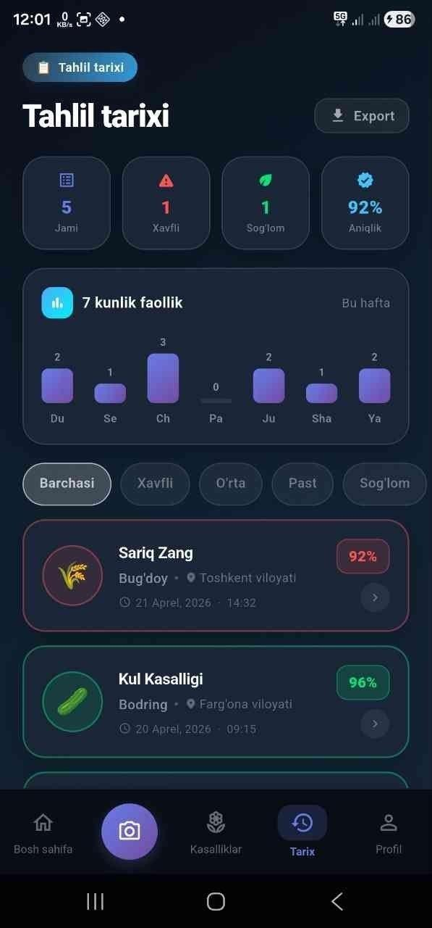
Figure 2.1. History screen — 7-day activity chart, filter chips, and analysis cards

3.4.4. Profile Screen
The profile screen shows the user's name (Ulugbek Abdumansurov), verified farmer badge, email, and phone. Below that are stats (12 analyses, 4 diseases found, 94% accuracy, 3 farms). Then there's an achievements section with 4 badges: First Analysis, 10+ Analyses, 90%+ Accuracy, Pro User. Below that are settings sections for language, notifications, theme, and biometric login.
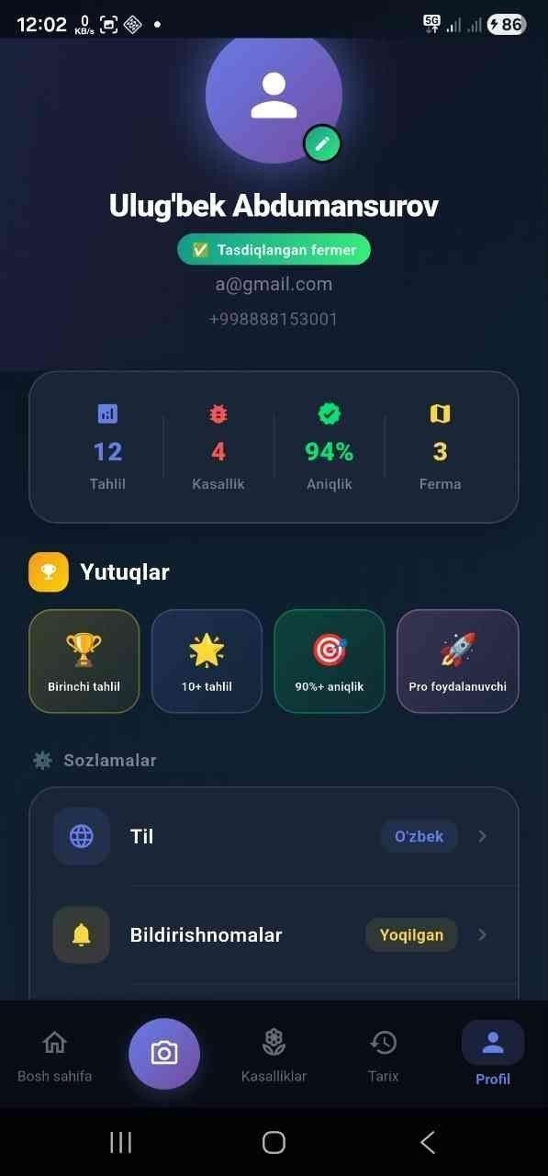
Figure 2.2. Profile screen — user info, achievements badges, settings menu

3.5. Multilingual Support
The app supports three languages: Uzbek, Russian, and English. This is handled by the easy_localization package. Every string in the UI is referenced by a key like 'nav_home'.tr() instead of a hardcoded text. The actual translations are stored in JSON files in the assets/translations/ folder.
Switching the language doesn't restart the app — it happens in real time. The language preference is saved in SharedPreferences so the app remembers it next time.
// How translations work in the code
Text('nav_home'.tr()) // shows 'Home' or 'Bosh sahifa'
Text('analyze_title'.tr()) // shows 'Analyze' or 'Tahlil qilish'
Text('result_healthy'.tr()) // shows 'Healthy Plant'
Text('result_disease_found'.tr()) // shows 'Disease Detected'

// Translation files: assets/translations/en.json assets/translations/ru.json
assets/translations/uz.json

3.6. Summary
The app is built in Flutter with a clean five-layer architecture.
MockMLService handles the AI detection logic and can be swapped for a real
TFLite model later. The go_router package manages navigation using a ShellRoute with five tabs. Riverpod manages state. The easy_localization package provides Uzbek, Russian, and English support.
The current version is a working prototype. The detection logic is mocked, but the full app flow — from uploading a photo to seeing the results and treatment advice — is completely functional. Future work includes integrating Firebase for real user accounts and history, and replacing MockMLService with a trained TFLite model.

Conclusion
In this thesis I designed and built GreenFarm AI, a mobile app that helps farmers detect crop diseases using artificial intelligence. The app supports 6 crop types, has a database of 12 diseases, and provides treatment recommendations in three languages.
The main things I accomplished:
- Built the full app architecture using Flutter, go_router, and Riverpod
- Designed and implemented MockMLService with a database of 12 diseases
- Created all 7 app screens with animations and proper UX
- Added multilingual support in Uzbek, Russian, and English
- Used a modern glassmorphism design that is clean and easy to read
- Implemented image picking from gallery and camera
- Built a history screen with weekly chart and severity filters

The current version uses a mock AI service because training a real model was outside the scope of this thesis. But the architecture is designed so that replacing MockMLService with a real TFLite model requires changing only one file.
Future plans include: connecting Firebase for real authentication and cloud storage, training a TFLite model on real plant disease images from Uzbekistan, adding push notifications for disease risk alerts, and integrating real weather API data.
I believe GreenFarm AI can make a real difference for farmers in Uzbekistan. Early disease detection can save a huge part of the harvest. The app is simple enough that any farmer with a smartphone can use it, and it works without internet connection in the field.

References
- Al-Haimi, B. et al. (2025). Digital transformation in agriculture. Review of AgriTech Technologies.
- Business Research Company. (2024). AI in Agriculture Market Report 2024–2029.
- Deloitte. (2023). Generative AI in agriculture: benefits, risks, and adoption.
Deloitte Insights.
- Deloitte. (2024). Agricultural technology outlook for 2025. Deloitte Insights.
- FAO. (2024). Artificial intelligence in agriculture — policy guidance.
https://www.fao.org
- Jafary, P. et al. (2025). Machine learning for crop disease detection.
Journal of Agricultural Research.
- Kandipati, A. (2025). Systematic review of AI applications in agriculture.
Journal of Agricultural Research.
- Li, Z. (2023). Random forest for crop classification. Highlights in Business, Economics and Management, 21, 934–938.
- Matterport. (2024). Modern approaches to agricultural monitoring.
Matterport Tech Blog.
- Netguru. (2025). How AI is transforming the agricultural landscape. netguru.com
- Russell, S. & Norvig, P. (2020). Artificial Intelligence: A Modern Approach, 4th ed. Pearson.
- Sharma, Harsora, Ogunleye. (2024). Comparison of ML algorithms for crop analysis. Analytics, MDPI, 3, 30–45.
- Smith, J. (2024). Technology strategies for modern farmers. Today's AgriTech News.
- Spot.uz. (2025). Uzbekistan's agricultural technology market. spot.uz
- Taylor, M. (2024). Modern approaches to crop disease detection.
AgriTech Times.
- Treleaven, P. et al. (2021). Agricultural data markets. AI and Ethics, 1, 445–462.
- Wu, A. et al. (2024). Improving farm management with big data and AI.
Journal of Big Data.
- Yazdani, A. (2021). Neural networks for plant disease detection. arXiv:2110.07151.
- Zillow Tech Hub. (2023). ML methodology comparison (reference for algorithm benchmarking). zillow.com/tech
- Daryo.uz. (2025). Uzbekistan agricultural market analysis, March 2025.
- Gazeta.uz. (2025). AI ethics norms in Uzbekistan. gazeta.uz
- MachineLearningMastery.com. (2025). Introduction to TFLite-based mobile models.

Appendix B. Disease Detection Pipeline Table 3.3. Step-by-step flow from photo to result
Step | Component | What happens
1 | AnalyzeScreen | User selects crop and uploads photo
2 | AnalyzeScreen | 2.2 second loading animation runs
3 | MockMLService | analyzeForCrop() filters diseases by crop type
4 | MockMLService | Returns random disease (88%) or healthy (12%)
5 | go_router | Navigates to /result with detection data
6 | AnalysisResultScreen | Shows disease, symptoms, treatment options
Source: compiled by author.

Affirmation
Hereby I, Abdumansurov Ulugbek, affirm that the Bachelor’s thesis was performed independently, without the assistance of others; sources of data and definitions taken from external sources are indicated in the thesis. This work has not been submitted to any other examination commission and has not been published elsewhere.
Riga, 2026

_______________ _____________________ signature Abdumansurov Ulugbek

Acknowledgments
The author expresses sincere gratitude to supervisor Professor Jelena Caiko for her invaluable guidance, constructive feedback, and continuous support throughout the development of this thesis.
Special thanks are extended to the faculty of the Department of Natural Sciences and Computer Engineering at Riga Nordic University for providing the academic foundation that made this work possible.
The author also thanks colleagues and fellow students whose discussions and peer-review contributions helped refine both the GreenFarm AI application and the written thesis.

